AASHTO Innovation Initiative
[Proposed] Nomination of Innovation Ready for Implementation

Sponsor

Nominations must be submitted by an AASHTO member DOT willing to help promote the innovation. If selected, the sponsoring DOT will be asked to promote the innovation to other states by participating on a Lead States Team supported by the AASHTO Innovation Initiative.
1. Sponsoring DOT (State): Georgia Department of Transportation
2. Name and Title: Andrew Heath, State Traffic Engineer
Organization: Georgia Department of Transportation
Street Address: 600 West Peachtree NW
City: Atlanta
State: Georgia
Zip Code: 30308
Email: aheath@dot.ga.gov
Phone: 404-635-2828
Fax: N/A

Innovation Description (10 points)

The term “innovation” may include processes, products, techniques, procedures, and practices.
3. Name of the innovation:
Analytics dashboard and platform for Automated Traffic Signal Performance Measures
4. Please describe the innovation.
Automated traffic signal performance measures (ATSPMs) are a suite of performance measures, data collection and data analysis tools to support objectives and performance based approaches to traffic signal operations, maintenance, management and design to improve the safety, mobility and efficiency of signalized intersections for all users. Originally pioneered through a pooled fund study with Purdue University and the Indiana Department of Transportation, and later implemented into an application by the Utah Department of Transportation, ATSPMs have revolutionized the way agencies maintain and operate their traffic signals. GDOT sought to build off this work by taking intersection-level data and aggregating it into a dashboard-based platform to reveal corridor and region-based performance measures, all by leveraging the foundational work of ATSPMs. This initially began as an effort to automate a monthly reporting process that was completed manually by a team of engineers. It has since evolved into a performance monitoring tool used by engineers to better maintain and operate the signal systems in the state of Georgia.
5. What is the existing baseline practice that the innovation intends to replace/improve?
Monthly executive and project reporting for GDOT’s Regional Traffic Operations Program (RTOP), now branded as SigOps, used to be done through many hours of manual data collection from field devices and even more hours of engineers scouring the data to produce aggregate data for a 200 page excel-based report. When GDOT implemented systems in their traffic signals that were capable of logging high resolution traffic signal event data, the opportunity existed for most of this reporting to be automated.
6. What problems associated with the baseline practice does the innovation propose to solve?
The amount of time that was required to produce the original reports was not at all in line with any benefits that were derived from the monthly reporting. Furthermore, the relationship between the reach of a signal operations engineer was limited to a linear scale. If the department wanted to expand its reach of proactive signal management, the resource input was not sustainable beyond its existing footprint. Introducing analytics tools like this SigOps dashboard expand the effectiveness of an engineer, providing broader situational awareness and directing their focus to the areas and systems that need it most.
7. Briefly describe the history of its development.
Automated Traffic Signal Performance Measures started in 2005 when Indiana Department of Transportation (INDOT) initiated research with Purdue University to develop performance measures that characterized flow rates, quality of coordination, and split failures using logged time-stamped detectors, phase changes, and controller events. During the development of these performance measures, the research team reached out to agency partners and vendors (Econolite, Siemens, and Peek) to develop a library of definitions for controller events as discussed above. This research resulted in a host of new performance measures that could be produced once all of the vendors were talking with the same language (https://docs.lib.purdue.edu/jtrpdata/3/), keeping the development of ATSPMs vendor neutral. Several other signal controller vendors have also incorporated ATSPMs into their traffic signal controllers and central systems. The Utah Department of Transportation developed a web-based application that used this data to produce performance measures. In 2014, UDOT lead an AASHTO Innovation Initiative (AASHTO Aii) on ATSPMs (http://aii.transportation.org/Pages/AutomatedTrafficSignalPerformanceMeasures.aspx) that helps to identify and champion the implementation and deployment of proven technologies, products or processes that are likely to yield significant economic or qualitative benefits to the users. UDOT lead this effort with assistance from Purdue University, INDOT, MNDOT, and the Federal Highway Administration (FHWA). Beginning in 2015 GDOT launched its own instance of ATSPM with the assistance of UDOT, providing free access to advanced corridor and signal metrics to engineers across the state. As of August 2019, over 6,500 traffic signals in Georgia provide this real-time data. In 2017, GDOT retained Kimley-Horn to further develop ATSPM as well as consolidate the controller event data and vehicle probe data into corridor-wide performance measures for monthly and quarterly trends for each RTOP corridor. Launched in January 2018, GDOT’s Measurement, Accuracy, and Reliability Kit (MARK 1) automated a manual reporting system for RTOP that had been in place for over five years, saving hundreds of hours in development each month and approximately $250,000 in annual savings. The public facing website allows engineers to track trends on an intersection, corridor, and programmatic level as well as visualize maintenance-related problems. Since its initial deployment the site has continued to expand to include corridors across the state and additional data visualization metrics. Following UTAH DOT’s example, GDOT has made the source code for this tool freely available to other agencies for use.
8. What resources—such as technical specifications, training materials, and user guides—have you developed to assist with the deployment effort? If appropriate, please attach or provide weblinks to reports, videos, photographs, diagrams, or other images illustrating the appearance or functionality of the innovation (if electronic, please provide a separate file). Please list your attachments or weblinks here.
The application can be found at http://sigopsmetrics.com/main/ and its open source repository can be found at https://github.com/atops/GDOT-Flexdashboard-Report.
Attach photographs, diagrams, or other images here. If images are of larger resolution size, please provide as separate files.
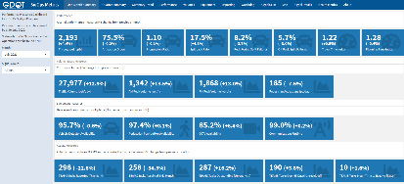 | 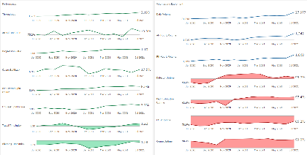 | 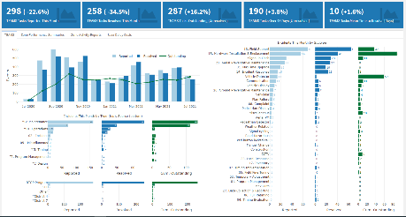
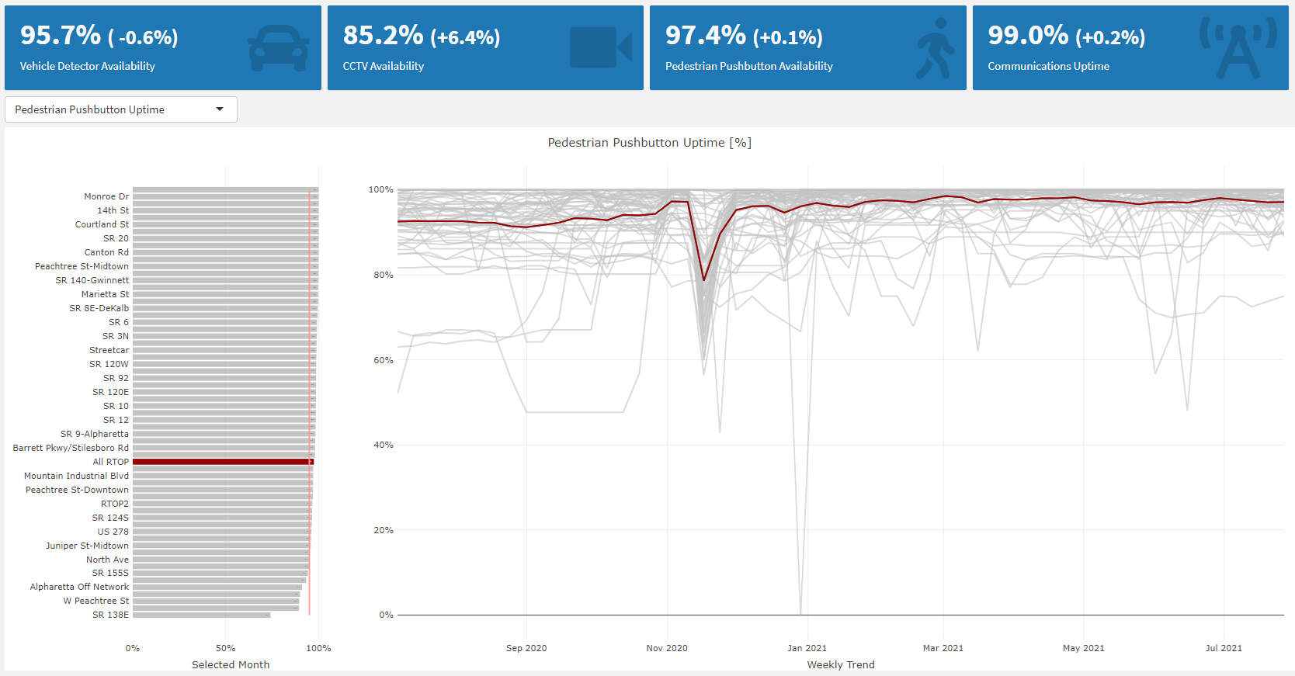 | 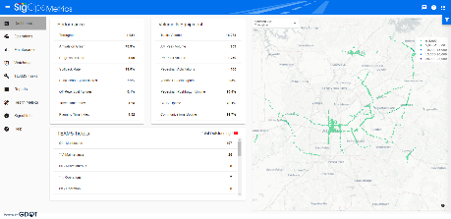 | 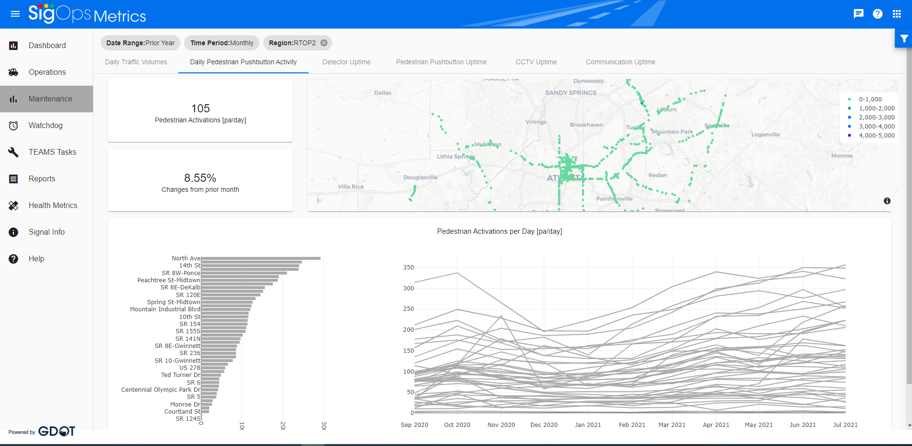


State of Development (40 points)

Innovations must be successfully deployed in at least one State DOT. The AII selection process will favor innovations that have advanced beyond the research stage, at least to the pilot deployment stage, and preferably into routine use.
9. How ready is this innovation for implementation in an operational environment? Please select from the following options. Please describe.
☐ Prototype is fully functional and yet to be piloted
☐ Prototype has been piloted successfully in an operational environment
☐ Technology has been deployed multiple times in an operational environment
☒ Technology is ready for full-scale implementation
Click or tap here to enter text.
10. What additional development is necessary to enable implementation of the innovation for routine use?
An agency will need to know how to implement this kind of system on their network as well as have traffic signal software that can support data feeds on this type.
11. Are other organizations using, currently developing, or have they shown interest in this innovation or of similar technology?? ☒ Yes ☐ No
If so, please list organization names and contacts. Please identify the source of this information.
Organization | Name | Phone | Email
Maricopa County DOT | April Wire | 602.506.7174 | april.wire@maricopa.gov
Click or tap here to enter text. | Click or tap here to enter text. | Click or tap here to enter text. | Click or tap here to enter text.
Click or tap here to enter text. | Click or tap here to enter text. | Click or tap here to enter text. | Click or tap here to enter text.

Potential Payoff (30 points)

Payoff is defined as the combination of broad applicability and significant benefit or advantage over baseline practice .
12. How does the innovation meet customer or stakeholder needs in your State DOT or other organizations that have used it?
The deployment of these applications is saving hundreds of hours in development each month. Additional savings are realized on other projects and programs through using data to eliminate unnecessary or redundant workflows. Operational issues are resolved remotely and more quickly using data tools, alleviating the need for costly and slow field evaluations. Additionally, the performance monitoring of the system is automated, giving a 24/7 overview of performance in near real-time, as opposed to snapshots based on floating car studies, for example. The activation of the technology and the corridor level metrics have enabled GDOT to better focus limited resources to where problems and issues are in the field. Timing issues are better addressed and more efficiently remotely resolved, and proactive response to operational and maintenance issues is dramatically enhanced. Response to customer complaints has become more instantaneous, enabling better communications to the public when issues arise. Continuing partnerships with other state agencies, like Utah DOT, have led to additional insights and metrics being developed. Georgia DOT will soon be deploying its first new signal performance metric, which helps measure available left turn gaps for permissive left turn movements. The development of that metric was done in close coordination with the Utah DOT.
13. Identify the top three benefit types your DOT has realized from using this innovation. Describe the type and scale of benefits of using this innovation over baseline practice. Provide additional information, if available, using quantitative metrics, to describe the benefits.
Benefit Types | Please describe:
Improved Operation Performance | Focusing operations engineers on where needs are highest, expanding their reach to additional traffic signals.
Improved Customer Service | Proactive response to maintenance and operations issues, correcting them before they substantially impact traveling public.
Improved Quality | Improved operations and maintenance of traffic signals and their systems.

Provide any additional description, if necessary:
Click or tap here to enter text.
14 How broadly might this innovation be deployed for other applications. in the transportation industry (including other disciplines of a DOT, other transportation modes, and private industry)?
Concept could be used as an aggregate endpoint for any kind of transportation data. Private industry can leverage the data to improve contract service provided to agencies.

Market Readiness (20 points)

The AII selection process will favor innovations that can be adopted with a reasonable amount of effort and cost, commensurate with the payoff potential.
15. What specific actions would another organization need to take along each of the following dimensions to adopt this innovation?
Check boxes that apply | Dimensions | Please describe:
☐ | Gaining executive leadership support | Click or tap here to enter text.
☒ | Communicating benefits | Visualizing and capturing empirical evidence of the benefit of TSMO and proactive traffic signal maintenance and operations.
☒ | Overcoming funding constraints | Leveraging technology to focus resources on primary needs and demonstrating tangible benefit to investments.
☒ | Acquiring in-house capabilities | It is built on a modern network system that requires current technical skills to integrate and operate.
☒ | Addressing legal issues (if applicable) (e.g., liability and intellectual property) | Agencies will likely need some form of NDA or data access agreement with third parties, depending on state code.
☐ | Resolving conflicts with existing national/state regulations and standards | Click or tap here to enter text.
☐ | Other challenges | Click or tap here to enter text.

16. Please provide details of cost, effort, and length of time expended to deploy the innovation in your organization.
Cost: $100,000
Level of Effort: Medium
Time: 2-4 weeks to stand up back-end system
17. To what extent might implementation of this innovation require the involvement of third parties, including vendors, contractors, and consultants? If so, please describe. List the type of expertise required for implementation.
Solution is open-sourced, but there are commercial offerings of similar products/systems. Systems support may be required by IT technical experts to implement and operate a container-based system and appropriate network protocols.

